ORTEC MODEL 874 QUAD COUNTER/ TIMER.

In very good operational condition, tested on all channels for stability and accuracy. Ideal for use with photomultipliers, gas proportional counters, ionization chambers and semiconductor diode detectors (APD's). Great instrument for multiple detector counting systems. Because of a few cosmetic issues and being an older model Quad Counter, I am offering it a greatly reduced price. It is, however, 100% functional and guaranteed. See below for various screen pics, specifications and features at bottom:
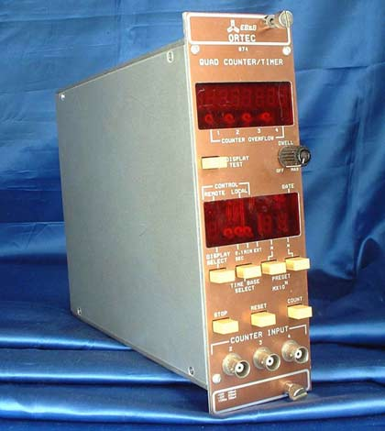

When I acquired this counter both side panels were missing, so I replaced them with some spares I had. The left panel (shown above) normally has some holes punched in the side to access the GPIB and serial port settings so you will now need to remove the panel if you wish to change these options. In the pics below, a pulse generator was connected to all three counting channel inputs and the timer preset was set to 10 seconds (Timebase Select=.1 Sec, M=1, N=2). Channel 1 always displays the Timer value as shown below and left. Counting channel 2 is below, right.

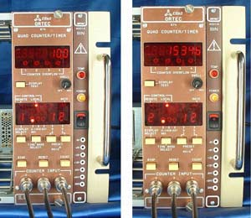

Counting channels 3 and 4 shown below and also displaying the same count as channel 2 as they should.
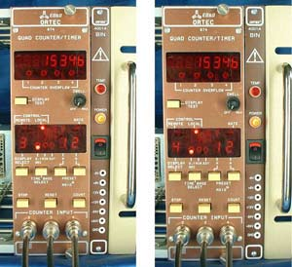

ORTEC MODEL 874 QUAD COUNTER/ TIMER SPECIFICATIONS
Maximum Count, Each Channel | 8 Decades
Time Base | 0.1 Sec, 1 Min or EXTERNAL Selectable
Maximum Timer Preset | 9 X 10 ⁷ (X Timebase Select)
Maximum Count Rate | 100 MHz Neg Going, 40 MHz Pos Going
Pulse Pair Resolution, Seconds | Inverse of Above Max Count Rates
Counter Input Thresholds | 1.5 Volts, Fixed
Counter Input Impedance | 1K Ohms
Dimensions | 11" x 2¾" x 8¾" (L x W x H)
Weight | 5.2 Lbs

ORTEC MODEL 874 QUAD COUNTER/ TIMER FEATURES

Three Simultaneous Counting Channels
Very Wide Timer Preset Range
Counter Overflow Indicators For Each Channel
Count Gate Indicator
Variable Dwell Time for Cyclic Counting (Turn OFF for 1 Preset Count)
Manual STOP, RESET, and COUNT Control
Fits Standard NIM Type Power Bins (Double-Wide Bay)

